9/27/2024

Zimmer, Michael J

ENG 2140-90

How to Install JetBrains IDEs

Instruction Guide

**Introduction**

These instructions explain step by step how to create a JetBrains account and install their different Integrated Development Environments (IDEs). JetBrains has a portfolio of different IDEs tailored specifically for different programming languages. By downloading one of their IDEs, a programmer will be much more effective as they learn the language and the capabilities of the IDE.

**Parts List**

Required parts for this task are:

* Computer
* Stable Internet connection
* Minimum 5GB of storage per IDE

**Instructions**

**Setting up your JetBrains account**

1. Go to <https://www.jetbrains.com/>.
2. Click on the silhouette of a human in the upper right hand corner of JetBrains website.
3. Enter your email under “Create JetBrains Account” and click “Sign Up” on the bottom right hand corner.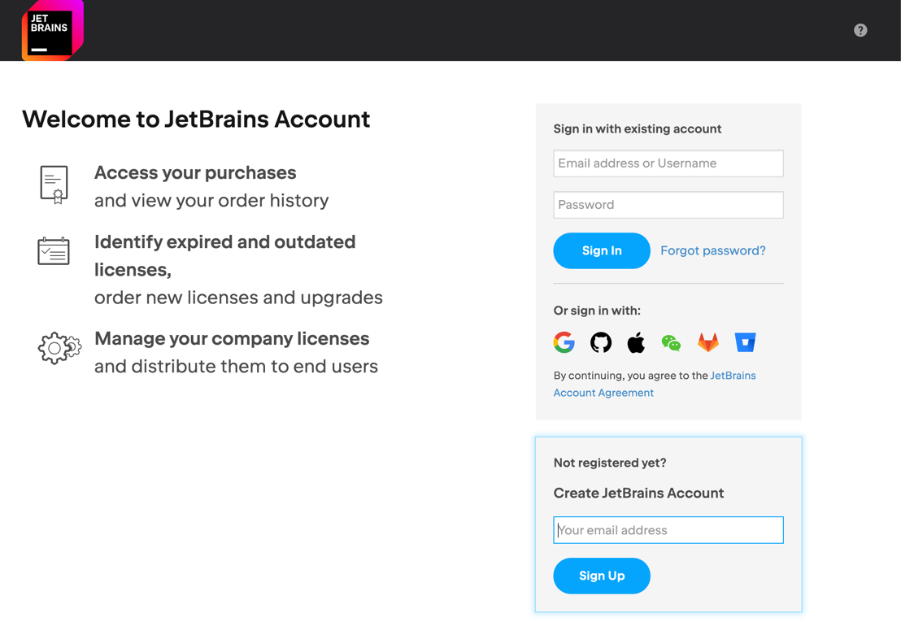
4. Go to the email you entered to access the confirmation email sent by JetBrains.
5. Follow the prompt in the email sent by JetBrains to finish registering your account.

**Warning: Do not, under any circumstances, share your email, username, or password with other people to protect yourself and your account.**

**Tip: Using a student account, such as a @wright.edu, will give you a free 1-year license to JetBrains’s IDEs. Confirm every year you are still enrolled to continue getting the free 1-year license**

**Tip: Once you are no longer a student, JetBrains sells the license for their IDE at a 40% discounted price.**

**Choosing and Downloading the Right IDE**

1. Click on “Developer Tools” at the top of the website on JetBrains home page.

1. Select “All IDEs” in the top left hand corner in the drop-down menu.
2. Scroll down on the new page and see the list of primary languages table.

Tip: You can also look at all the different IDEs available at once, however the primary languages table is helpful to narrow down which IDE best suits your desired language.

1. Choose your preferred primary language from the table. This will display between one and three different options.
2. View the different languages the IDEs support to see if the IDE will meet the needs of your project or goals.Screens screenshot of a phone

   Description automatically generated
3. Click the “Download” button once you have decided.
4. Choose your preferred operating system (Windows, MacOS, or Linux).
5. Choose the type of file to download.

* Windows has the options: .exe (Windows), .zip, and .exe (ARM64)
* MacOS has the options: .dmg (Apple Silicon) and .dmg (Intel)
* Linux has the options: .tar.gz (Linux) and .tar.gz (Linux ARM64)

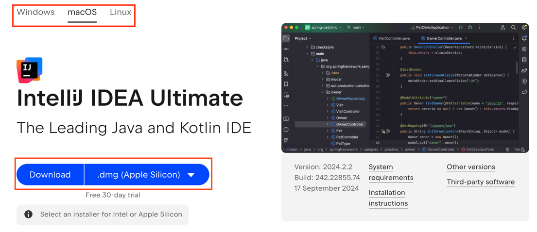

1. Click “Download” once preferred operating system has been chosen.
2. Continue with the common steps of downloading any new file on your specific operating system.

**Conclusion**

With your newly downloaded IDE, you are able to unlock the secrets of effective coding with the JetBrains IDE of your choice. While free universal IDEs exist (such as VS Code and Eclipse, which require the user to download plugins for certain language support), an IDE made to work with specific languages and their common counterparts is a strong tool for novice and experienced programmers alike.